Indigenous Strategy Roadmap 2023–2025

Acknowledgement of Traditional Owners
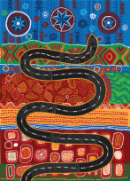

“Travelling” by Gilimbaa

The Department of Transport and Main Roads acknowledges the Traditional Custodians of the land and waterways. We pay respects to their ancestors and Elders, both past and present. The Department of Transport and Main Roads is committed to reconciliation among all Australians.
Statement on the use of respectful terminology
We recognise that Aboriginal peoples and Torres Strait Islander peoples each have their own unique languages, beliefs, cultural practices, traditions, and diversity within each culture.
This document includes a range of collective terms to reference and reflect the unique identity of Aboriginal peoples and Torres Strait Islander peoples. The primary term that has been used is Aboriginal and Torres Strait Islander peoples, with other terms used including First Nations people of Queensland, First Nations and Indigenous.
Creative Commons information

Copyright: This publication is protected by the Copyright Act 1968. © State of Queensland, 2023. Third party copyright: Third party material that is not licensed under a Creative Commons licence is referenced within this document: all photographs are all rights reserved. Please contact the Department of Transport and Main Roads (the copyright owner) if you wish to use this material.

The material in this work is licensed by the Department of Transport and Main Roads under a Creative Commons Attribution 4.0 International licence (CC BY 4.0), with the exception of:
- the Queensland Coat of Arms
- this department’s logo
- any third party material, and
- any material protected by a trademark.
More information on the CC BY licence is set out as follows:
- Creative Commons website –www.creativecommons.org
- Attribution 4.0 international (CC BY 4.0)–https://creativecommons.org/licenses/by/4.0/

Disclaimer: While every care has been taken in preparing this publication, the State of Queensland accepts no responsibility for decisions or actions taken as a result of any data, information, statement of advice, expressed or implied, contained within. To the best of our knowledge, the content was correct at the time of publishing.
Translating and interpreting assistance

If you need an interpreter call the Translating and Interpreting Service (TIS National) on 131 450. If you are deaf or have a hearing or speech impairment, contact us through the National Relay Service: www.relayservice.gov.au.

Contents
Contents 3
Foreword from the Director-General 3
Message from the General Manager 5
Vision 6
Key focus areas 6
Laying the foundations 6
Building together 7
Bridging the digital divide 7
Staying on the road 8
Indigenous champion groups 9
Overview of how Indigenous Champion Groups will prioritise reframing the relationship 10
Strategic Commitments 11
Capability Development and Learning 9
People Attraction and Employment 9
Procurement and Business Engagement 10
Customer Facing and Community 10
Governance and Reporting 11
Structural Reform 11
Conclusion 14

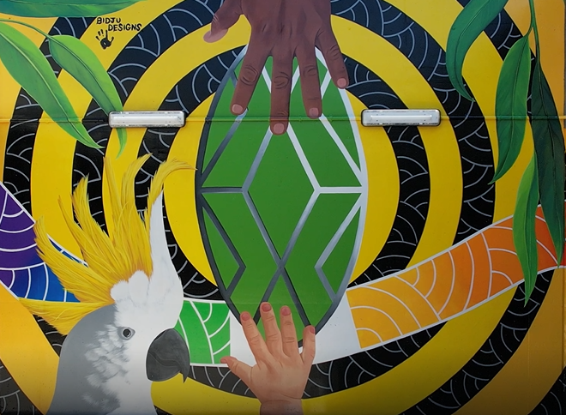
Image: Townsville Ring Road Stage 5 Underpass artwork by Nicky Bidju Pryor. Design credit: Wulgurukaba people.

Foreword from the Director-General
It is with the upmost pride and pleasure that I present the Department of Transport and Main Roads’ (TMR) Indigenous Strategy Roadmap. The Roadmap provides strategic direction for authentic co-design of an accompanying implementation plan that will step out the operational actions required to position TMR as a ‘better practice’ agency.
I have had the honour of continuing the legacy of my predecessor, Neil Scales, in developing this departmental strategy for how TMR can improve its workplaces and service delivery with Aboriginal peoples and Torres Strait Islander peoples. Neil has a motto to “stay on the road” and I am proud to see his vision continued in this strategy.
Under Neil’s leadership, TMR has achieved incredible outcomes through our relationships with First Nations people, businesses and communities. We’ve seen TMR projects help build the capability of First Nations businesses and see employment opportunities stay in community. We’ve seen the implementation of the critically important Indigenous Driver Licencing Unit who deliver essential licencing, identification and road safety services to remote and discrete First Nations communities to increase employment options and hopefully reduce the road related incarceration rates. We’ve partnered with Sea and Land Rangers that results in First Nations people caring for Country in a mix of traditional and modern practices. And our internal fundraisers have supplied BBQ’s, books and playground equipment to community centres in Woorabinda, the community where TMR was Government Champion for nine years. I can’t tell you how excited I am to be Government Champion for Napranum in 2024.
Our recent inclusion of the Queensland Government’s Customer and Digital Group with a far-reaching program will help bridge the digital divide and connect Queenslanders wherever they choose to live, work and play.
This strategy seeks to build on those successes. We are at a pivotal time in history and my aim for this strategy is to be a catalyst for authentic listening and meaningful change across the department. As public servants, I want TMR employees to be proud of the community outcomes they are all contributing to.
Throughout my own cultural awareness journey, I have heard over and over that now is the time to listen. As a Director-General, as a non-Indigenous person, and as a Queenslander – now is the time for me to listen. What I have heard so far is that we must better understand what our service delivery and workplaces are like for First Nations people before we plan how to improve them. We must better understand First Nations peoples, cultures, customs and communities before we plan how to strengthen our relationships with them.
This plan holds space to listen to First Nations perspectives and provides a framework that when it does come time to act, proposes incremental changes that will drive significant impacts when delivered in partnership with First Nations people. After all, from little things, big things grow.
‘It’s time to work hand-in-hand towards a united Queensland’
Sally Stannard
Director-General, Department of Transport and Main Roads

Message from the General Manager
Throughout my 40+ years at the Department of Transport and Main Roads I have travelled across this great state and have had the pleasure to meet and build relationships with many different Aboriginal and Torres Strait Islander peoples and communities.
I have seen first-hand how systemic tweaks to the process can have massive positive benefits to First Nations people of Queensland.
In 2021, our then Director-General asked me to review the efforts TMR was doing for Aboriginal and Torres Strait Islander customers and staff, recognising the need for a renewed focus and commitment in this space. With that, the Indigenous Strategy Team was created with a goal to increase visibility of our current initiatives, identify opportunities to maximise our resources, in order to create sustainable socio-economic outcomes with First Nations people.
Our goal is to have the Indigenous Strategy Roadmap embedded in our everyday core business, so our service delivery considers and includes Aboriginal and Torres Strait Islander peoples, communities and businesses.
While TMR can be proud of the many achievements we have made to date, the path forward must be different to the paths previously taken.
This is not just another project to deliver. It is a true reframing of the relationship between Aboriginal and Torres Strait Islander peoples and the Queensland Government.
As government employees and public servants, it is important we strive for excellence with culture at the centre, and that is what this Roadmap aims to achieve. It is through our people at TMR that wonderful things can happen, and we can collectively flourish beyond the solid foundations established in pockets across the state.
Queensland is on the precipice of history right now.
As a department we recognise that in the spirit of healing, we need to learn from our shared history through truth-telling, as we move forward together towards a stronger and brighter Queensland. We are working closely with our fellow agencies in striving to meet the Queensland Government’s Reconciliation targets together.
TMR is committed to this new way of working together with Aboriginal and Torres Strait Islander peoples that delivers real change and real outcomes, through a reframed relationship based on genuine partnership, as we continue the journey towards reconciliation and treaty.
The Indigenous Strategy Roadmap guides the way forward and allows us to get on with the job.
‘Working together to better support the capability of Queensland mob’
Bill Lansbury
General Manager, Indigenous Strategy
Department of Transport and Main Roads

Vision
At Transport and Main Roads (TMR), our vision is to create a single integrated network accessible to everyone.
We believe that all Queenslanders, irrespective of where they live and work, can expect to have appropriate transport choice, fair access to the transport system and digital inclusiveness.
We acknowledge there are barriers to achieving that in remote, discrete and Aboriginal and Torres Strait Islander communities.
TMR is committed to removing those barriers by reframing our relationship with Aboriginal and Torres Strait Islander peoples.
The vision of the Indigenous Strategy Roadmap is to create a robust framework that increases our potential to deliver positive socio-economic outcomes with Aboriginal and Torres Strait Islander peoples, businesses, and communities.
Our goal is to have a workplace that represents the community it services, provides a welcoming and safe space for all its customers and workforce (employees and contractors), and celebrates the diverse and unique cultures of the First Nations people of Queensland.

Key focus areas
- Increase the number of employees who identify as Aboriginal and/or Torres Strait Islander
- Increase training and career progression opportunities with Aboriginal and Torres Strait Islander employees
- Increase the procurement spend with and number of Aboriginal and Torres Strait Islander businesses
- Improve our workforce’s awareness of Aboriginal and Torres Strait Islander cultures and shared history

Laying the foundations
We know that solid foundations are critical to robust and sustainable infrastructure. The foundations of the Indigenous Strategy Roadmap highlight the importance of reframing the relationship with Aboriginal and Torres Strait Islander peoples by understanding, acknowledging, respecting and celebrating First Nations people, cultures and knowledge.
The foundations of the Indigenous Strategy Roadmap have been designed to strengthen the departments cultural capability as a necessary foundation to the pillars of voice, treaty and truth.
It was designed to align with the eight key components of the Queensland Government’s reframing the relationship plan. The plan was developed by members of the department’s Indigenous Strategy Working Group, which includes representation from Aboriginal and Torres Strait Islander employees, as well as Divisional and Branch Program Leaders.

Building together
Since colonisation, the Government has been setting agendas, implementing programs, and making decisions for Aboriginal and Torres Strait Islander peoples. In recent history, various reports have demonstrated that the failures of previous programs are partly due to the lack of genuine partnership in decision making with Aboriginal and Torres Strait Islander peoples.
The time to approach things differently is now.
TMR is on a learning journey. As a department, we are committed to the ongoing process of reconciliation, and reframing the relationship between Aboriginal and Torres Strait Islander peoples and the Queensland Government.
We recognise that reframing those relationships can only occur when they are based on respect and trust. To demonstrate its ongoing investment in fostering mutually beneficial relationships, the department engaged with Aboriginal and Torres Strait Islander employees when developing the Indigenous Strategy Roadmap.
Additionally, an internal First Nations Reference Group was formally established to provide First Nations employees the opportunity to:
- act as key internal stakeholders for engagement and co-design on programs, policies, practices, procedures, and related systems that impact Aboriginal and Torres Strait Islander peoples
- provide an Indigenous perspective and cultural insights into responses for TMR on matters relating to Aboriginal and Torres Strait Islander peoples
- support building cultural capability through education across all levels of TMR’s workforce
- develop professional skills, opportunities, and experiences.

Bridging the digital divide
As the world moves increasingly online, digital inclusion is necessary for people to be engaged in economic, social and civic life. Despite that reality, many Queenslanders remain significantly excluded from the digital world through lack of infrastructure access, affordability issues, or lack of ability to use technology. The digital divide is felt most acutely in geographically isolated Aboriginal and Torres Strait Islander communities.
Through Queensland’s Digital Economy Strategy, TMR’s priority is to close the digital divide to provide the opportunity for everyone to enjoy the economic and social benefits of a digitally-enabled economy.
Improved digital connectivity can provide new opportunities ‘On Country’ for First Nations communities to participate in flexible training and employment. The associated uplift in digital literacy and skills within the community can also drive additional employment, innovation and entrepreneurship, and enable a thriving local economy.
By enabling First Nations communities to embrace digital technology’s potential we empower people to build a prosperous future while staying connected to family, culture and country.

Staying on the road
The Indigenous Strategy Roadmap adheres to the new Public Sector Act 2022 and is strongly guided by the strategic direction and renewed commitments outlined by both the Australian and Queensland Governments.
By signing the National Agreement to Closing the Gap between First Nations and non-Indigenous Australians, all Australian states and territories have committed to addressing the key priority reforms and socio-economic targets outlined in the plan.
The Queensland Government’s Reconciliation Action Plan 2023-25 outlines targets focused on the pillars of Relationships, Respect, Opportunity, and Accountability (Governance) which includes the eight components required to reframing relationships, supported by the Path to Treaty process.
The Indigenous Strategy Roadmap is aligned to and includes the departments contributions towards delivering its commitments in the following whole-of-government initiatives:
- Queensland Government’s Reconciliation Action Plan 2023-25
- National Agreement on Closing the Gap
- Reframing the Relationship Plan
- Paving the Way: First Nations Training Strategy
- Many Voices: Aboriginal and Torres Strait Islander Languages Policy
- Commonwealth Aboriginal and Torres Strait Islander Workforce Strategy
- Queensland Procurement Strategy 2023
The Indigenous Strategy Roadmap endeavours to assist the department in meeting existing and emerging legislative obligations and instruments of authority, including but not limited to:
- Public Sector Act 2022
- United Nations Declaration on the Human Rights of Indigenous Peoples
- Native Title Act 1993
- The Torres Strait Islander Cultural Heritage Act 2003
- Aboriginal Cultural Heritage Act 2003
- Human Rights Act 2019
- Nature Conversation Act 1992.
It also provides an agile and responsive governance framework which includes regular reporting and annual strategic reviews to adjust and enliven targets as required.

Indigenous champion groups
In developing a plan to deliver sustainable outcomes for Aboriginal and Torres Strait Islander peoples, a coalition of departmental area leaders and divisional representatives was created to ensure the targets are purpose driven and achievable, while remaining agile and aspirational.
Six Indigenous champion groups (ICG) were established to cover the breadth of employment and transport services the department offers, and to collaborate efforts that work towards creating culturally safe customer services and workplaces.
Figure One: six Indigenous champion groups of TMR
Changing the organisation by taking a systemic approach
Capturing and sharing data to promote accountability
Customer Facing and Community
Creating inclusive workplaces and service delivery, while also connecting communities
Creating opportunity and growth with First Nations businesses
Procurement and Business Engagement
People Attraction and Employment
Creating employment opportunities for First Nations people
Creating learning opportunities of First Nations cultures
Structural Reform
Governance and Reporting
Capability Development and Learning
Aboriginal and Torres Strait Islander perspectives are included in core business

Overview of how ICGs will prioritise reframing the relationship

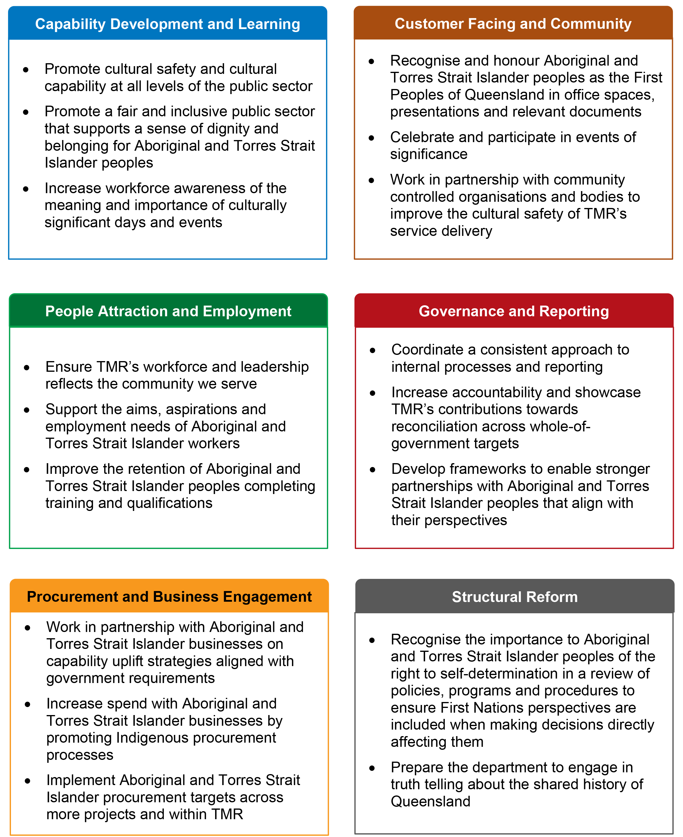

Strategic Commitments
Capability Development and Learning
The purpose of the Capability Development and Learning Indigenous Champion Group is to mature the cultural capability of TMR’s workforce to enable Aboriginal and Torres Strait Islander perspectives into everyday business.
The group seeks to increase workforce understanding, awareness, appreciation, promotion, and respect of Aboriginal and Torres Strait Islander cultures by providing accessible cultural capability and anti-racism training and information.
Current actions
Advance TMR’s cultural capability to ensure workplaces are culturally safe and TMR services are responsive to the needs to Aboriginal and Torres Strait Islander peoples, communities and businesses
Promote cultural safety by enacting anti-discrimination legislation and anti-racism strategies
Future intentions
TMR continues to reframe its relationships with Aboriginal and Torres Strait Islander peoples, communities and businesses to ensure ongoing respectful engagement

People Attraction and Employment
The purpose of the People Attraction and Employment Indigenous Champion Group is to have TMR’s workforce better represent the community it serves.
The group seeks to ensure TMR’s employment and retention programs are culturally inclusive and provide long term career development pathways for Aboriginal and Torres Strait Islander peoples.
Current actions
Increase the number of Aboriginal and Torres Strait Islander peoples joining and/or remaining within TMR’s workforce annually
Better understand and decrease the disparity in career progression among the Aboriginal and Torres Strait Islander workforce
Future intentions
Build stronger relationships with Aboriginal and Torres Strait Islander businesses and communities to promote employment opportunities
Be an employer of choice for Aboriginal and Torres Strait Islander peoples
Increase the number of senior leadership positions (>A08) filled by Aboriginal and Torres Strait Islander peoples
Procurement and Business Engagement
The purpose of the Procurement and Business Engagement Indigenous Champion Group is to create economic opportunities that support Aboriginal and Torres Strait Islander businesses to thrive.
The group seeks to leverage and strengthen relationships with Aboriginal and Torres Strait Islander businesses, and embed feasible procurement practices and capability uplift strategies that enable increased economic opportunities with Aboriginal and Torres Strait Islander supply chain businesses, including participation on Government contracts.
Current actions
Improve procurement processes that encourage and enable Aboriginal and Torres Strait Islander businesses to tender
Increase engagement with Aboriginal and Torres Strait Islander businesses to build capability to deliver government contracts
Future intentions
Increase procurement spend and the number of Aboriginal and Torres Strait Islander businesses engaged by TMR
Improve relationships between TMR procurement community and Aboriginal and Torres Strait Islander businesses

Customer Facing and Community
The purpose of the Customer Facing and Community Indigenous Champion Group is to ensure TMR services are delivered appropriately and in partnership with Aboriginal and Torres Strait Islander, where relevant.
The group seeks to ensure Aboriginal and Torres Strait Islander perspectives are considered in the design, delivery and evaluation of public facing programs and services.
Current actions
Promote and celebrate Aboriginal and Torres Strait Islander cultures, to create culturally welcoming and inclusive workplaces and services across TMR
Deliver services in partnership with Aboriginal and Torres Strait Islander communities
Future intentions
Embed Aboriginal and Torres Strait Islander perspectives in customer and community services through co-design and engagement
Update relevant policies to include better representation of Aboriginal and Torres Strait Islander peoples and cultures
Governance and Reporting
The purpose of the Governance and Reporting Indigenous Champion Group is to provide a cohesive framework for the implementation of and reporting on the Indigenous Strategy Roadmap which aims to embed Aboriginal and Torres Strait Islander perspectives across TMR’s policies and procedures.
The group seeks to understand TMR’s reporting requirements from across government and identify opportunities to ensure quality data and considered insights are being effectively reported on.
Current actions
Cleanse data and streamline reporting processes to improve TMR’s reporting against whole-of-government targets
Create agile governance frameworks that work to embed Aboriginal and Torres Strait Islander considerations in TMR’s core business
Future intentions
Create frameworks to capture learnings that can be shared across the state
Consider Aboriginal and Torres Strait Islander data sovereignty impacts in reporting requirements and narratives
A reporting system that complements the work programs of TMR to provide near real-time intel on performance across the business
Structural Reform
The purpose of the Structural Reform Indigenous Champion Group is to embed a culture of commitment and shared responsibility for reframing the relationship between Aboriginal and Torres Strait Islander peoples and the Queensland Government.
The group seeks to deliver an agile strategy where innovation, learning and reform is encouraged and where Aboriginal and Torres Strait Islander perspectives are incorporated into TMR’s strategic direction, policies, practices and plans.
Current actions
Promote structural reform to improve inclusion of Aboriginal and Torres Strait Islander perspectives in TMR’s core business practices, policies and procedures
Prepare the department for truth telling and healing
Future intentions
Embed a culture of continuous improvement when driving positive outcomes with First Nations customers and employees
First Nations cultures and perspectives are embedded into business-as-usual practices across all of TMR

Conclusion
TMR is committed to a new way of working with Aboriginal and Torres Strait Islander peoples that travels together in a spirit of continuous improvement.
This Indigenous Strategy Roadmap seeks to stitch together the positive outcomes the department has already achieved and build on our mutually beneficial relationships with Aboriginal and Torres Strait Islander peoples, businesses, and communities to create even greater outcomes.
An accompanying Action Plan will be co-developed with internal First Nations employees and other subject matter experts, applying the Roadmap as a framework. The actions and targets outlined will be achievable and realistic, and successful implementation will see TMR leverage opportunities to recognise the past, respect one another, and reframe our relationship with Aboriginal and Torres Strait Islander peoples of Queensland.
As public servants we are navigating unchartered waters and seeking a clear passage for all of our workforce to sail together towards a brighter future for all Queenslanders.
Hand in hand, we will continue forward together.

