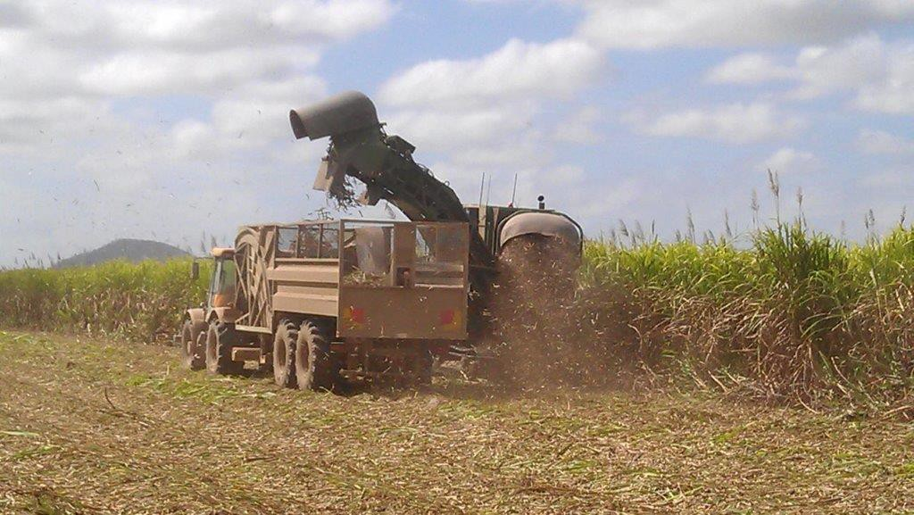

Registered Queensland Sugar Mill Mass Concession Scheme Participation Guide

Creative Commons information
© State of Queensland (Department of Transport and Main Roads) 2015
http://creativecommons.org.licences/by/4.0/
This work is licensed under a Creative Commons Attribution 4.0 Licence. You are f ree to copy, communicate and adapt the work, as long as you attribute the authors.
The Queensland Government supports and encourages the dissemination and exchange of information. However, copyright protects this publication. The State of Queensland has no objection to this material being reproduced, made available online or electronically but only if it's recognised as the owner of the copyright and this material remains unaltered.
The Queensland Government is committed to providing accessible services to Queenslanders of all cultural and linguistic backgrounds. If you have difficulty understanding this publication and need a translator, please call the Translating and Interpreting Service (TIS National) on 13 14 50 and ask them to telephone the Queensland Department of Transport and Main Roads on 13 74 68.
Disclaimer: While every care has been taken in preparing this publication, the State of Queensland accepts no responsibility for decisions or actions taken as a result of any data, information, statement or advice, expressed or implied, contained within. To the best of our knowledge, the content was correct at the time of publishing.

Contents
- Introduction 1
- Operations covered by this guideline 1
- Why do we need a Sugar Mill Mass Concession Scheme? 1
- Who administers the Sugar Mill Mass Concession Scheme? 2
- How does the Scheme work? 2
- How do the Scheme loading tolerances work? 2
- Gross Concession Masses 3
- Which trucks are eligible for loading tolerances? 4
- Operating conditions 4
- Recording and reporting 5
- Heavy Vehicle National Law, Safety Duties and Chain of Responsibility 6
- Managing overloaded vehicles 7
- Liaison visits 7
- General enquiries 7
- Definitions 8

Introduction
Queensland Government introduced the Registered Queensland Sugar Mill Mass Concession Scheme (the Scheme) to improve the efficiency of sugar harvest and address the difficulty of accurately loading heavy vehicles on-farm with bulk sugarcane. It aims to protect the road infrastructure network and promote road safety by reducing severely overloaded heavy vehicles through appropriate administrative procedures and compliance activities.
The Scheme operates on a year-to-year basis f rom 1 July to 30 June and benefits the sugar industry, the road transport industry and the wider community. It is designed to help manage uncertainties (varying moisture contents and densities) by providing drivers and vehicle owners with f lexibility above regulation mass limits. Part icipants with an active interest in the Scheme are:
  - Department of Transport and Main Roads (TMR)
  - Sugar mills
  - Harvester contractors
  - Haulage contractors
  - Local regional councils

Operations covered by this guideline
This guideline covers the road transport of sugarcane during harvest, f rom nominated farms which are serviced by the participating sugar mill.
Sugar mills listed in Schedule 1 of the Queensland Class 3 Sugar Mill Mass Management Scheme Exemption Notice 2021 (No.1) (the Notice) sign a Memorandum of Understanding (MoU) and agree to operate within the conditions listed in the MoU and the Participation Guide. The sugarcane will be harvested and transported by prime mover semi-trailer and B-double combinations to the mill. The vehicles transporting sugarcane operate under the Notice and will be identified by a Certificate of Participation. Vehicle mass data will be provided by the weighbridge and the sugar mill will provide the documented reports and registers for compliance assurance. TMR will review the documents to ensure the sugar mill is fulf illing the MoU and scheme conditions.
The Scheme is dependent on all parties involved complying with the agreed standards and conditions set out below. The extent of compliance to these standards and conditions, by the sugar mill and individual parties, will be the basis for reviewing viability of the Scheme.

Why do we need a Sugar Mill Mass Concession Scheme?
Overloading heavy vehicles is a safety issue and must be minimised to protect our road infrastructure network. The Scheme benefits the sugarcane industry, the road transport industry and the wider community. It allows an efficient sugarcane harvest while protecting road infrastructure through eliminating severe overloading. Through appropriate administrative procedures and compliance activities, the Scheme ensures reasonable road access is maintained
for rural economic development and social needs.

Who administers the Sugar Mill Mass Concession Scheme?
The Notice operates under section 117 of the Heavy Vehicle National Law (HVNL). This law is administered by the National Heavy Vehicle Regulator (NHVR). TMR and participating sugar mills are involved in the management, administration and operation of the Scheme in Queensland. The sugar mills administer and coordinate the
following aspects of the Scheme’s operation:
  - Certificate of Participation
  - Local council road approvals
  - Harvesters
  - Haulers
  - Recording and reporting
  - Administrative duties associated with the above tasks
TMR will coordinate the performance monitoring and review of the Scheme. TMR will visit sugar mills annually to conduct reviews and educate staff or discuss any issues associated with the Scheme so that there is a consistent application across all areas. This will also allow improvement ideas to be discussed directly with TMR and maintain positive working relationships between all stakeholders. Growers, contractors and transport operators wishing to participate in the Scheme need to enquire with a participating registered sugar mill listed in Schedule 1 of the Notice.

How does the Scheme work?
Sugar Mills listed in Schedule 1 of the Notice have agreed to work with TMR under a formalised MoU to ensure the Scheme’s viability and success.
The day-to-day operation is to be administered by the sugar mill in accordance with their MoU and the Registered Queensland Sugar Mill Mass Concession Scheme Participation Guide (Participation Guide).
Registered sugar mills weigh all vehicles at the point of delivery, compile and forward reports to TMR.
Sugarcane deliveries that exceed the mass limits of the Scheme will need to be managed by the mill in accordance with safety duties and Chain of Responsibility (CoR) obligations. The sugar mill should not provide any incentive,
f inancial or otherwise, for trucks to arrive overloaded to their facilities.
Evaluation of the Scheme involves measuring vehicle compliance with the MoU based on the reports and registers required to be made available to TMR, and the vehicle mass as assessed at the sugar mill or during a roadside intercept.

How do the Scheme loading tolerances work?
Heavy vehicles operating in the Sugar Mill Mass Concession Scheme are to be loaded according to regulation mass limits wherever possible. The tolerance applied under the scheme is an in-f ield loading tolerance not a productivity concession. If registered in the scheme, vehicles are afforded the following scheme mass limits and will not incur a penalty if intercepted on road or record these masses occasionally at a weighbridge:
  - 7.5 per cent maximum f lexibility on regulation gross vehicle mass for the combination.
  - 10 per cent maximum f lexibility on regulation axle/axle group masses; and

The maximum steer axle mass of a heavy vehicle must not be more than;

    - 6.6 tonne; or

    - the manufacturer’s steer axle mass rating
Note: Irrespective of the scheme mass limits, vehicles cannot exceed their manufacturer’s gross or axle mass rating.

Vehicle manufactured with Front Under-run Protection (FUP) are entitled to 6.5 tonnes on the steer axle, however the 10% loading tolerance does not apply to FUP vehicles as a maximum of 6.6 tonnes is permitted.
Additionally, 0.05% tonne is not added to the Gross Concessional Mass Limits for a vehicle manufactured with FUP.

Gross Concession Masses
General Mass Limits and Gross Concession Mass Limits are listed in the table below:

Vehicle Types | General Mass Limit | Gross Concession Mass
5 Axle semitrailer  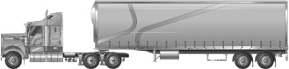 | 39.00t | 41.90t
Common 6 axle semitrailer  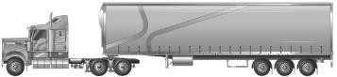 | 42.50t | 45.70t
8 axle B-double  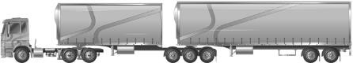 | 59.00t | 63.40t
9 axle B-double  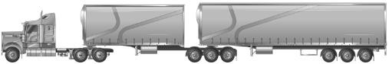 | 62.50t | 67.20t

Which trucks are eligible for loading tolerances?
Scheme loading tolerances are only to be applied to vehicles enrolled in a Registered Queensland Sugar Mill Mass Concession Scheme.
Loading tolerances cannot be applied unless the sugar mill has a signed MoU with TMR, and the vehicle is enrolled in a Registered Queensland Sugar Mill Mass Concession Scheme.

Operating conditions
All vehicles operating under the Notice are to comply with these operating conditions.

Area operating conditions
  - Vehicles operating under the Notice must only travel on authorised routes.

Range
  - Vehicles operating under the Notice are not to travel on roads that are more than 200km in radius f rom the delivery point.

Wet weather closures and road works
  - Vehicles operating under the Notice are to automatically revert to regulation mass limits, or specified mass, in the event of prolonged rain affecting the routes permitted under the MoU. These limits will remain until such day and time as may be determined by a representative of the Director General, Department of Transport and Main Roads.
  - It is the responsibility of the haulage contractor to contact TMR and/or the relevant local government authority to seek clarification regarding road infrastructure access in the event of prolonged rain or road works. Recorded information on wet weather road closures or road works is available 24 hours a day, seven days a week by phoning 13 19 40, via the QLD Traffic website or relevant local government website.

Local authority roads
  - For vehicles operating under the Notice, the sugar mill must have and approval permit f rom the National Heavy Vehicle Regulator for the use of local Road Manager roads and routes through towns/cities.
  - The Road Manager approval must have commencement and expiry dates.
  - A copy of the Road Manager approval is to be supplied during each yearly audit.
  - The approved routes must be carried in the vehicle or produced electronically when operating under the Registered Queensland Sugar Mill Mass Concession Scheme.

Vehicles operating under the MoU
  - Vehicles transporting sugarcane for the sugar mill must comply with the Notice and the Participation Guide to be eligible for the scheme mass concessions.
  - Vehicles transporting sugarcane must be an eligible vehicle and enrolled in a Registered Queensland Sugar Mill Mass Concession Scheme with a sugar mill listed in Schedule 1 of the Notice.
  - While operating under the Notice and carting sugarcane to scheme tolerances the following items must be carried in the vehicle or produced electronically, Certificate of Participation issued by the sugar mill and a copy of the Notice.

Manufacturer rating
  - Vehicles operating under the Notice must not exceed the manufacturer ratings.
  - These ratings include Gross Vehicle/Combination Mass, steering ratings, brake capacities, suspension ratings and tyre ratings.

Even Distribution of Loads
  - Harvester, loaders and vehicle drivers/operators are responsible for even distribution of loads over their vehicle combination, and axles or axle groups.

Registration Gross Mass
  - All vehicles operating under the Notice must be registered.
  - Prime movers with acceptable manufacturer’s ratings, capable of utilising the mass concession must be registered to their required registration mass for the vehicle combination as determined by TMR.

Certificate of Participation
  - The sugar mill is to issue each vehicle with a Certificate of Participation indicating the vehicle's allowable mass concession limits, and a copy of the Queensland Class 3 Heavy Vehicle Sugar Mill Mass Management Scheme Exemption Notice 2021 (No.1). A record of the registration details of each vehicle issued a certificate is to be kept in the Register for Vehicles Operating under the Agreement.
  - All vehicles operating under the Notice are to have a Certificate of Participation and a copy of the Queensland Class 3 Heavy Vehicle Sugar Mill Mass Management Scheme Exemption Notice 20 21 (No.1) in the vehicle when operating under the Scheme.

Weighing of vehicles
  - The sugar mill weighbridge/s must have a current calibration certificate when loads are being accepted with scheme tolerances applied and must be able to produce evidence of calibration upon request by TMR.
  - The sugar mill is to ensure that all vehicles operating under the Notice have their loads weighed each time they transport the product.

Axle/axle groups
  - Vehicles operating under the Notice must be:
    - f itted with four tyre axles in their suspension configurations, except for steer axles; and

    - f itted with conforming axle/axle groups.

Recording and reporting
The sugar mill is required to compile and make available to TMR, the reports and registers detailed below. All vehicle mass data included in the reports are to be based on actual weighbridge mass data.

Register of Eligible Vehicles Operating under the MoU (Seasons Carters List)
A copy of this register is to be forwarded to TMR prior to the commencement of a season and upon any subsequent changes to the register throughout the duration of this MoU. Each season this register is to include:
- Certificate of Participation and vehicle owner’s details for each vehicle operating under the concession.

- Registration number, tare and registered gross mass of all vehicles operating under the Scheme.

- Manufacturer's vehicle mass rating;

- The code/s that are issued to each vehicle combination.

- Date issued and date withdrawn

Weekly Concessional Mass Management Compliance Report

This report is to be compiled and forwarded electronically each week to TMR. The report is to include:

- total number of loads within general mass limits;

- total number of loads within gross concession mass limits;

- total number of loads delivered exceeding gross concession mass limits;
- a summary showing the abovementioned loads, the total loads delivered for the week and the percentage of the loads exceeding the gross concessional mass limits.

Harvester Contractor Weekly Summary Report

This report is to be compiled and forwarded to TMR each week. The report is to include:
- total number of deliveries loaded by each harvesting group up to or equal to gross concessional mass limits;
- Loads exceeding gross concessional mass limits;

- Percentage of compliance to the above mass categories.

Harvesting Groups Operating Under the MoU Register
A copy of this register is to be forwarded to TMR prior to the commencement of a season and upon any subsequent changes to the register throughout the duration of this MoU. This register is to record the details of:
- Harvesting group details

- Participation agreement details.

Heavy Vehicle National Law, Safety Duties and Chain of Responsibility
In accordance with the agreement to self -regulate, the sugar mill is to take the necessary action to control and correct non-compliance incidents and also to operate within the Heavy Vehicle National Law including CoR requirements.
The aim of CoR is to make sure everyone in the supply chain shares responsibility for ensuring breaches of the HVNL do not occur. Under CoR laws if you are named as a Party in the chain, you exercise (or have the capability of exercising) control or inf luence over any transport task, you have a responsibility to ensure the HVNL is complied with. The law recognises that multiple parties may be responsible for offences committed by the drivers and operators of heavy vehicles. A person may be a party in the supply chain in more than one way. For example, they may have duties as the employer, the operator and the consignee of goods.
The principles applying to the Safety Duties are set out in Heavy Vehicle National Law and Involved Parties should educate themselves of their obligations and make use of the tools available on the NHVR website. The NHVR CoR Gap Assessment Tool enables you to examine business practices and systems controls against known risks and recognised best practice. Based upon the responses provided the tool will generate a list of recommendations for consideration.

Cane spillage poses a safety risk on the road network. As part of your CoR obligations you should actively refer all operators to the National Transport Commission’s Load Restraint Guide 2018 to ensure there is appropriate load restraint that prevents incidence of cane spillage whilst in transit to your site.

Managing overloaded vehicles
TMR will prioritise compliance and enforcement activity primarily at non-compliant operators. Any vehicles operating under the Notice found to be severely overloaded during a roadside inspection will be issued a Prohibition Notice and grounded until the load on the heavy vehicle combination is adjusted to the Notice mass concession limits.
Sugarcane deliveries that exceed the mass limits of the Scheme will need to be managed in accordance with Safety Duties and CoR obligations.
If possible, safely unload the truck at the depot. However, the sugar mill should not provide any incentive, f inancial or otherwise, for trucks to arrive overloaded to their facilities in the f irst place and must actively manage their supply chain to comply with the HVNL, Safety Duties and ensure the overloading doesn’t continue.
What should you do?
  - Delivery instructions and contractual arrangements with their supply chain should be performance reviewed to ensure systems are in place by all parties to mitigate risks of this happening.
  - Formal documented conversations or incident reports between parties are a good way of managing individual one-off incidents to ensure they are not repeated and demonstrate management of your safety obligations.
  - Focus should be directed on each individual occasion a vehicle arrives over its scheme mass at the sugar mill, encouraging parties to work with other members of the transport supply chain (e.g. consignor, harvester, haulier) to manage their Safety Duties and ensure it doesn’t hap pen again.
  - If vehicles operating under the Notice are repeatedly found to be not complying with the processes outlined in the Participation Guide, the sugar mill's MoU can be amended, suspended or cancelled through a show cause process.

Liaison visits
TMR will visit sugar mills annually to conduct reviews and educate their staff or discuss any issues associated with the Scheme so that there is a consistent application across all areas. This will also allow improvement ideas to be discussed directly with TMR and maintain positive working relationships between all stakeholders .
TMR officers will provide at least three days notification of intention to visit for audit purposes.
TMR officers may visit the sugar mill weighbridge to talk to drivers and discuss the operations. TMR must notify the sugar mill of the intention to visit. All personnel must follow the sugar mill visitor’s policy by reporting to the administration office or contacting the on-site officer or the shift supervisor after hours.

General enquiries
Please telephone the Senior Transport Inspector (Toowoomba) on (07) 4617 743 for general enquiries about the Participation Guide.

Definitions

Terms | Meaning
Axle: | A single axle
Axle group: | A single axle, a tandem axle group, a triaxle group, and a twin steer axle group
Axle mass: | The total mass transmitted to the road by the tyres f itted to an axle group
Gross mass: | The maximum permissible mass specified by the manufacturer of a loaded vehicle or vehicle combination
Mass concession: | The maximum permissible mass per axle group or gross mass allowed to vehicles participating in the Sugar Mill Mass Management Scheme
Gross Mass Concession: | The permissible mass allowed on a loaded vehicle or vehicle combination participating in the Registered Queensland Sugar Mill Mass Concession Scheme
Axle/axle group – mass concession: | The permissible mass transmitted to the road by the tyres f itted to an axle group of a vehicle participating in the Registered Queensland Sugar Mill Mass Concession Scheme
General Mass Limits (GML): | General mass limits determined by the Heavy Vehicle (Mass, Dimension and Loading) National Regulation. Common heavy f reight vehicle combinations.
Loading tolerance: | A permissible variation in mass applied to in-f ield loading.
Minimum registration: | The minimum permissible mass, mass determined by TMR, of a loaded vehicle combination required to operate under industry self -regulation scheme
Measurement adjustment: | The measurement adjustment applies to a heavy vehicle when being weighed for on-road compliance. Measurement adjustment recognises that mass assessment outcome may potentially vary f rom time to time due to the:  - Weighing and measurement equipment used  - Inspection site characteristics  - Measuring methods  - Conditions under which the measurements were made  Measurement adjustment values can be found on the National Heavy Regulator (NHVR) internet website at www.nhvr.gov.au
The Scheme: | Registered Queensland Sugar Mill Mass Concession Scheme.
The Notice: | Queensland Class 3 Heavy Vehicle Sugar Mill Mass Management Scheme Exemption Notice 2021 (No.1)

